Name:Vasavi S Puranik
USN:1BM24CS320

Employee Database
1.Using Scheme diagram, Create tables by properly specifying the primary keys and the foreign keys
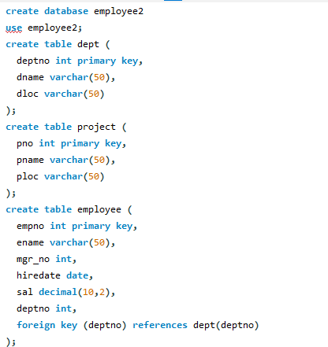
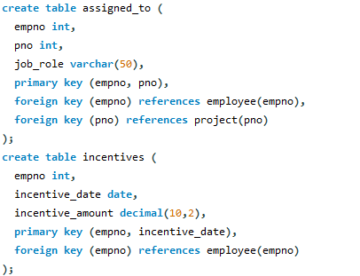
2. Enter greater than five tuples for each table.
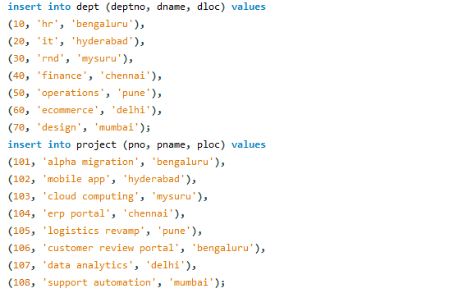
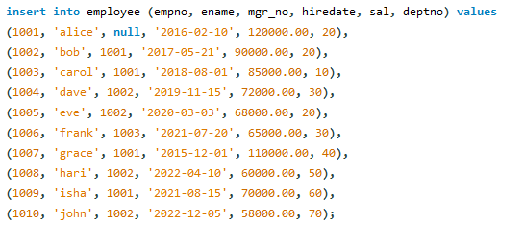
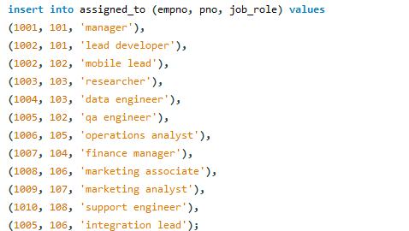
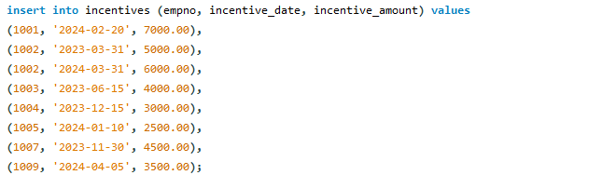
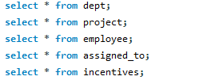
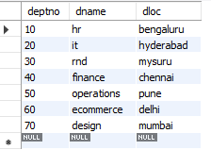
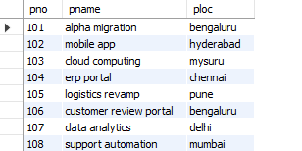
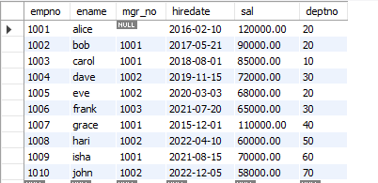
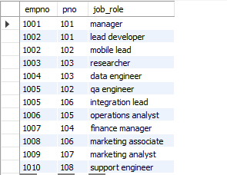
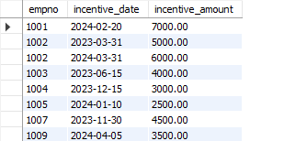
3. Retrieve the employee numbers of all employees who work on project located in Bengaluru, Hyderabad, or Mysuru
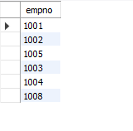
4. Get Employee ID’s of those employees who didn’t receive incentives
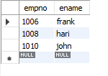
5. Write a SQL query to find the employees name, number, dept, job_role, department location
and project location who are working for a project location same as his/her department
location.
